Experiment 1

https://github.com/PRASHIRAWAL/R-Programming-Experiment-1

Task 1: Import and Inspect the Dataset
Display the first six records
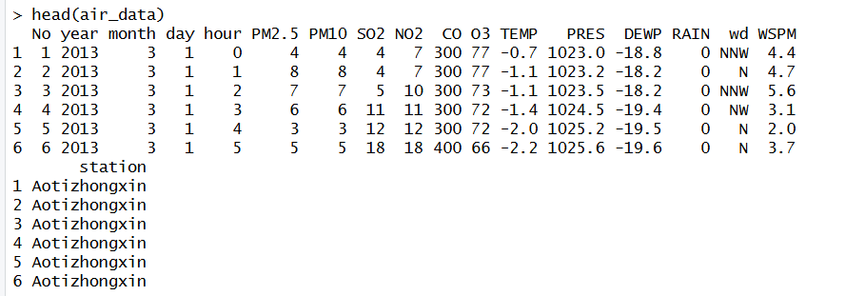
Display the structure of the dataset
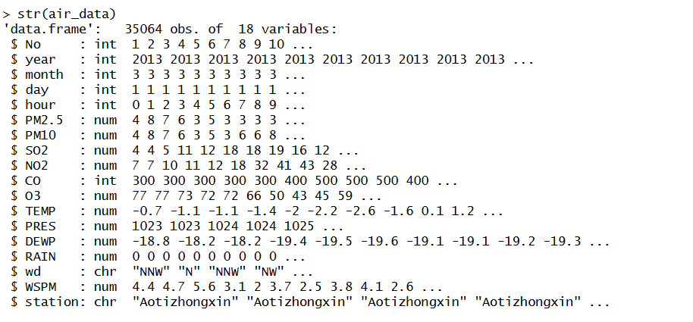
Display the number of rows and columns, check whether the dataset contains missing values and display the total number of missing values.
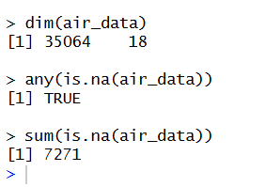

Task 2: Understand NA, NULL, and NaN
NA indicates a missing observation, NULL represents an empty object, and NaN indicates an undefined numerical result. The corresponding functions correctly identified each value type.
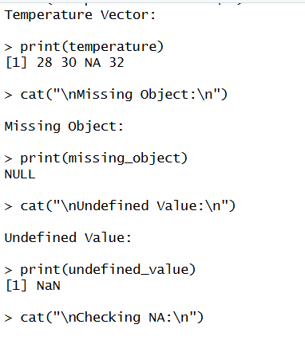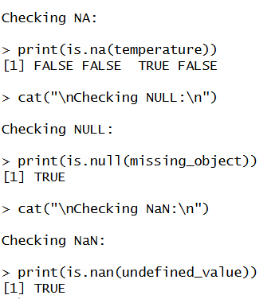

Task 3: Create a Missing-Value Summary Function
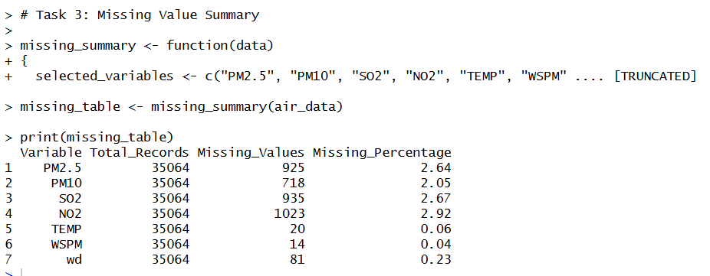

Task 4: Identify Invalid Numerical Results
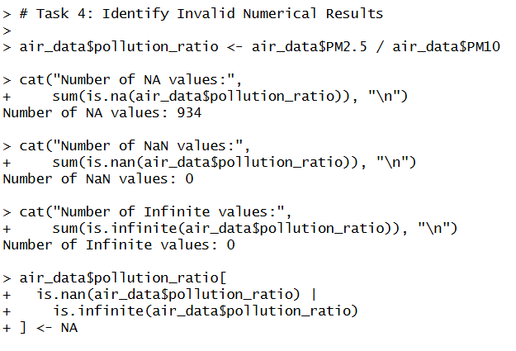
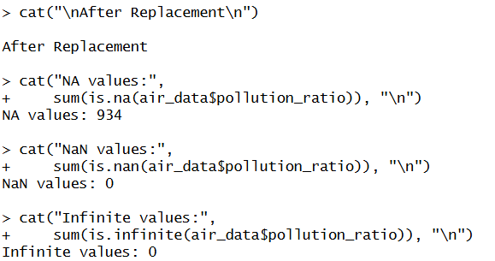

Task 5: Handle Missing Numerical Values Using a Loop
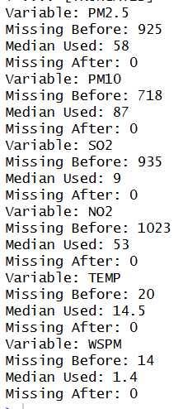

Task 6 – Handle Missing Categorical Values
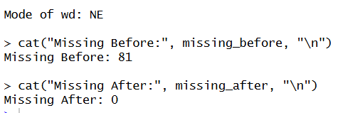

Task 7 – Implement Error Handling
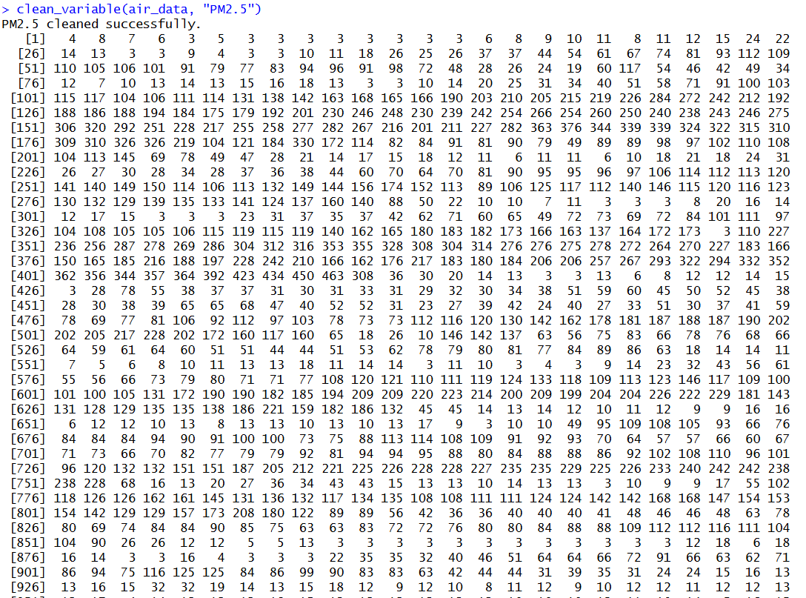
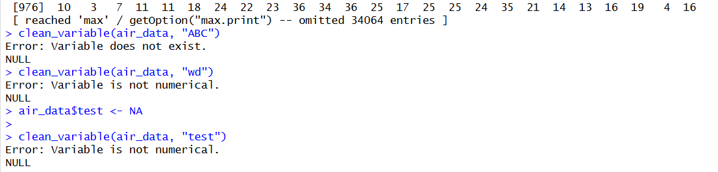

Task 8 – Compare Missing Values Before and After Cleaning
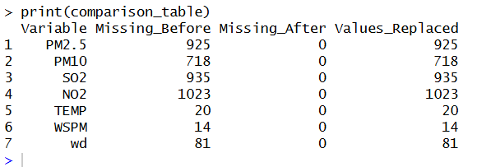

Task 9 – Generate One Visualization
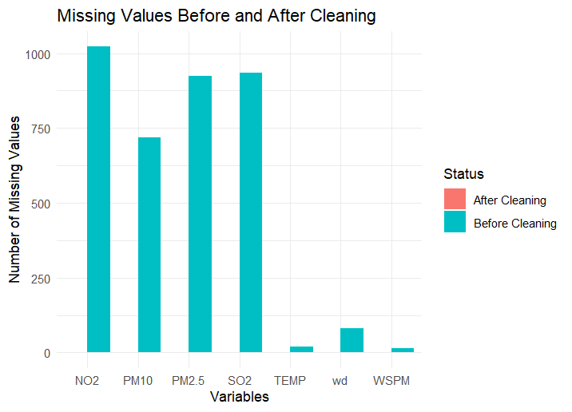

Task 10 – Export the Cleaned Dataset
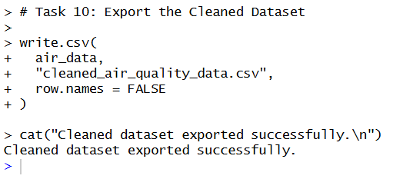

The Beijing Multi-Site Air Quality dataset was successfully cleaned using R programming techniques. Missing values in numerical variables were identified and replaced using the median, while missing values in the categorical variable wd were replaced using the mode. A user-defined function was developed to summarize missing values and another function with tryCatch() was implemented to handle errors gracefully. A comparison table and bar chart confirmed that all selected variables were free of missing values after cleaning. The cleaned dataset was then exported for future analysis. This experiment demonstrated the practical use of loops, functions, conditional statements, error handling and data preprocessing techniques in R.

This experiment provided practical experience in cleaning real-world datasets using R. It demonstrated how to identify and handle different types of missing values (NA, NULL and NaN), apply median and mode imputation, create reusable functions, use loops to avoid repetitive code and implement robust error handling using tryCatch(). The cleaned dataset was successfully exported and is ready for further statistical analysis or machine learning applications.

